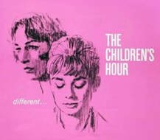

This Week’s Afternoon Schedule for The Children’s Hour

Mon., 4:15 – 5:15
Cast: All
Crew: Set, Costumes, Props, Lights, Sound, Publicity

Tues., 4:15 – 5:15
Cast: All
Crew: Set, Costumes, Props, Lights, Sound

Weds., 4:15 – 5:15
Cast: All
Crew: Set, Costumes, Props, Lights, Sound, Publicity

Thurs., 4:15 – 5:15
Cast: All
Crew: Set, Costumes, Props, Publicity

Fri., 4:15 – 5:15
Cast: All
Crew: Set, Costumes, Props

