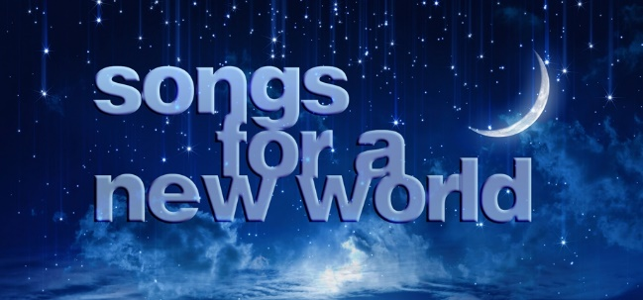

CAST
Baritone: Emerson Weiler
Alec Slade
Tenor: Juan Romero
Eli Brandt
Mezzo: Bella Apodaca
Olivia Kendall
Soprano: Jennelle Hall
Gillian McCreery
Siena Massaro
Ella Tremblay

To accept your role in this show, please join us for the production meeting on Fri., 1/8,
9:00-10:30am, via Google Meets (LINK). Scripts will be available at the front entry of FCHS beginning Friday afternoon. Please stop by to get yours as soon as possible.
Questions? Email Mr. Tyler (jtyler@psdschools.org)

CREW
Stage Manager: Nessa Pause
Set Lead: Sage Spry
Set Assistant Lead: Tanner Bennett
Set Crew: Aidan Ackerson
Quinn Campbell
Peyton Keefe
Cam Kurtz
Lexy Lambert
Morgan Marin
Eddie Tyler
Lizzie Vacante
Lilia Whitman
Marketa Young
Lights Crew: Katie Brown
Katy Hicks
Sawyer Hill
Violet Kuhlman
Sydney Peirce
Brooklyn Shepard
Ellie Swain
Vincent Yourshaw
Grace Wade

CREW
Costumes Co-Lead: Isabel Anderson
Costumes Co-Lead: Logan Sedran
Assistant Costumes Lead: Ali Steen
Costumes Crew: Kathryn Attkisson
Kalub Blodgett
Caleb Cripe
Auden Henning
Lin LaMonte
Susie Land
Lexi Mivshek
Lin Novak
Jesimae Rojas
Brynn Seidle
Avery Smith
Hannah Tautkus
Publicity Lead: Eugene Worford
Publicity Crew: Sydney Eubank
Zoe Halseide
Greta Jones
Kennen Wageman

CREW
Film Production Lead: Aidan Ellison
Film Production Crew: Max Allan
Tyler Guggemos
Carmen Henderson
Sky Hume

To accept your role in this show, please join us for the production meeting on Fri., 1/8, 9:00-10:30am, via Google Meets (LINK). Questions? Email Mr. Tyler (jtyler@psdschools.org)

