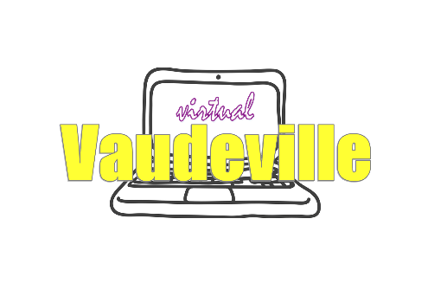

cast

TECH / ACT ASSIGNMENTS
Tech Team 1: Lead – Sydney Eubank Crew – Quinn Campbell, John Wood,
Auden Henning
Act 1: Bella Apodaca “Everything’s Coming Up Roses” from Gypsy
Act 12: Madison Knott “Cecily Smith” from Fly By Night

Tech Team 2: Lead – Tyler Guggemos Crew – Cara Cluver, Emily Fox-Million,
Devin Scoggins
Act 2: Kathryn Attkisson “Maybe” from Annie
Act 13: Susie Land Musical Solo *

Tech Team 3: Lead – Sawyer Hill Crew – Eddie Tyler, Logan Sedran,
Lilia Whitman
Act 3: Katie Brown, Ellie Swain, Aidan Ellison, & Truman McCaw “Do You
Wanna Ride? from Be More Chill
Act 14: Siena Massaro “Don’t Rain On My Parade” from Funny Girl

Tech Team 4: Lead – Maraya Kankel Crew – Sean Rodriguez, Zoe Halseide,
Lauren Oraym
Act 4: Aidan Ellison & Emerson Weiler “Two Player Game” from Be More Chill
Act 15: Briery McCoy “She Used to be Mine” from Waitress

Tech Team 5: Lead – Florence Luevano Crew –Aidan Ackerson, Kalub Blodgett
Act 5: Jennelle Hall “What Baking Can Do” from Waitress
Act 16: Gillian McCreery “God Help the Outcasts” from Hunchback of Notre Dame

Tech Team 6: Lead – Miranda McAulay Crew – Vincent Yourshaw, Greta Jones,
Juan Romero
Act 6: Carmen Henderson “I Don’t Need a Roof” from Big Fish
Act 17: Lexi Mivshek & Gabe Stadtmueller “Someday” from Hunchback of Notre Dame

Tech Team 7: Lead – Nessa Pause Crew – Lin LaMonte, Marketa Young,
Cameron Kurtz
Act 7: Katy Hicks Monologue from An Ideal Husband
Act 18: Malia Schonfeld “Stupid With Love” from Mean Girls

Tech Team 8: Lead – Sage Spry Crew – Brooklyn Shepard, Morgan Marin,
Max Allan
Act 8: Danielle Juarez “So Big So Small” from Dear Evan Hansen
Act 19: Alec Slade & Lizzie Vacante “Fine” from Ordinary Days

Tech Team 9: Lead – Keiran Wisell Crew – Hannah Tautkus, Sydney Peirce,
Lien Bradley
Act 9: Peyton Keefe Monologue *
Act 20: Avery Smith Musical Solo *

Tech Team 10: Lead – Eugene Worford Crew – Grace Wade, Lexy Lambert,
Ruby Chase
Act 10: Olivia Kendall “Astonishing” from Little Women
Act 21: Ali Steen Monologue from She Kills Monsters

Tech Team 11: Lead – Sky Hume Crew – Zona Dunlap, Corinne Dressler,
Violet Kuhlman
Act 11: Olivia Kendall and Ella Tremblay "Sonya and Natasha" from Natasha, Pierre
& the Great Comet of 1812
Act 22: Kennen Wageman “Once Upon a December” from Anastasia

